Quick-Demo Tour Video

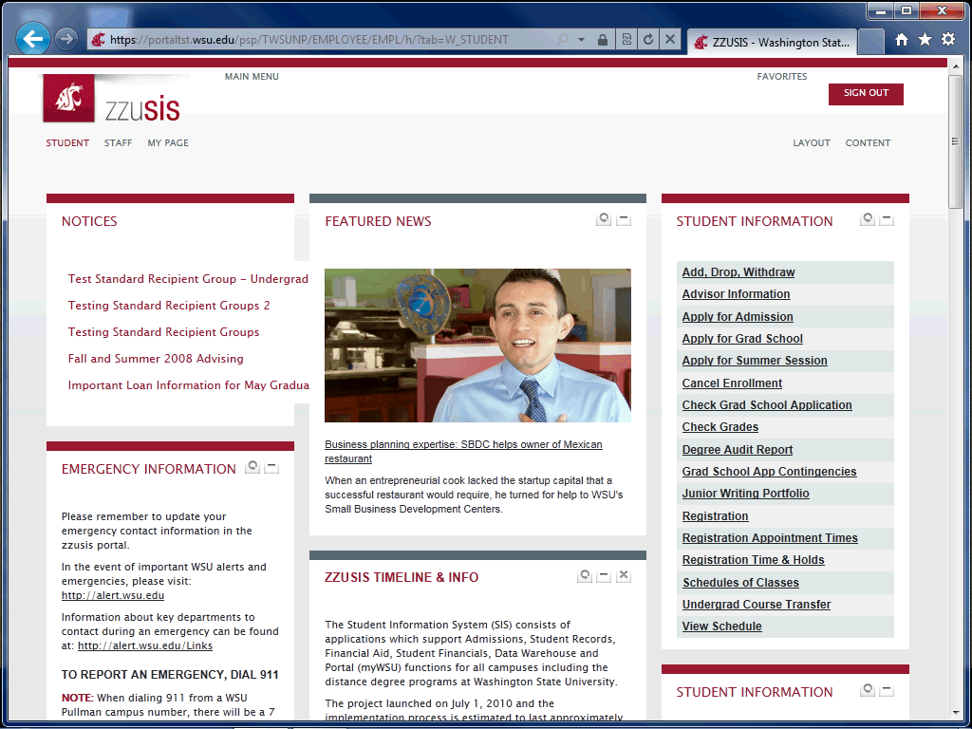

Step | Action
 | After you log into the zzusis portal, you see your home tab. In this case, this zzusis user is a student, so they see a "Student" tab. This tab has default content such as Notices, Featured News, and Student Information. A faculty member sees a "Faculty" tab, and a WSU employee sees a "Staff" tab.
 | All zzusis portal functionality can be accessed throught the Main Menu.
 | If you can't find a function on your tabs, you can find it in the Main Menu, by scrolling through the menus.
 | Search is another way to quickly find what you're looking for.
 | To access your "My Page" tab, click here.
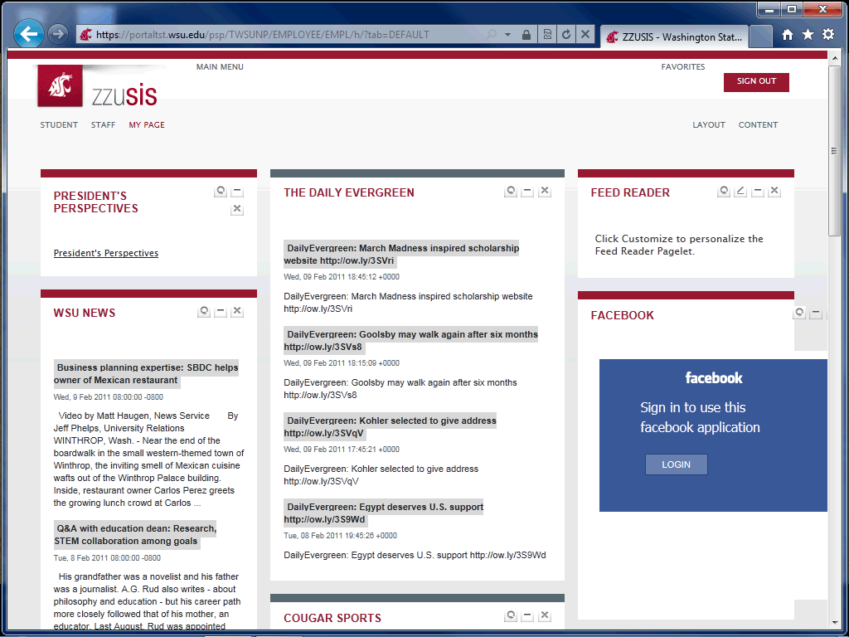

Step | Action
 | The "My Page" tab is designed to be customized by the user. Each user should use this tab for items they would like to see regularly. For example, this student is defaulted to see the Feed Reader, Facebook, President's Perspectives, WSU News, andThe Daily Evergreen.
The boxes that display on each tab are called "pagelets." Pagelets can be moved, customized, added, and deleted. Click the refresh icon to refresh the content in the pagelet.
Release the mouse button.
 | Click the "Minimize" icon to temporarily hide the content of the pagelet.
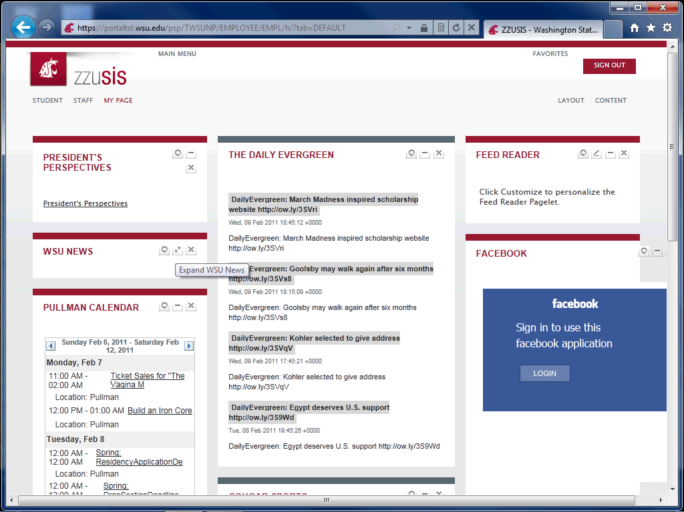

Step | Action
 | Click the "Expand" icon to restore the pagelet.
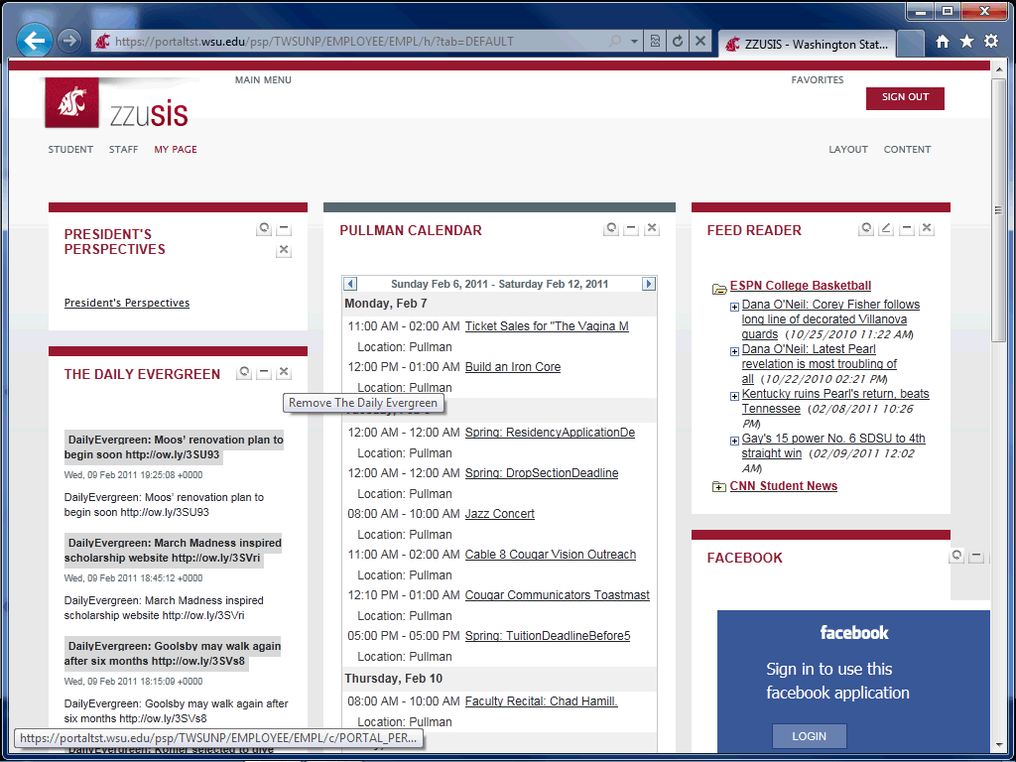

Step | Action
 | Click the "close" icon to remove the pagelet from your tab.
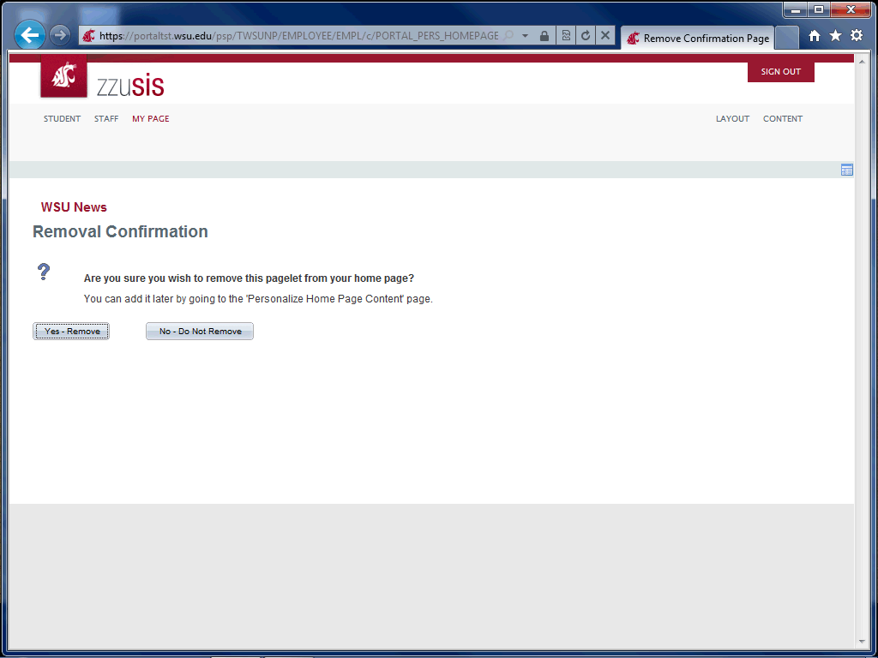

Step | Action
 | Click the Yes - Remove button.
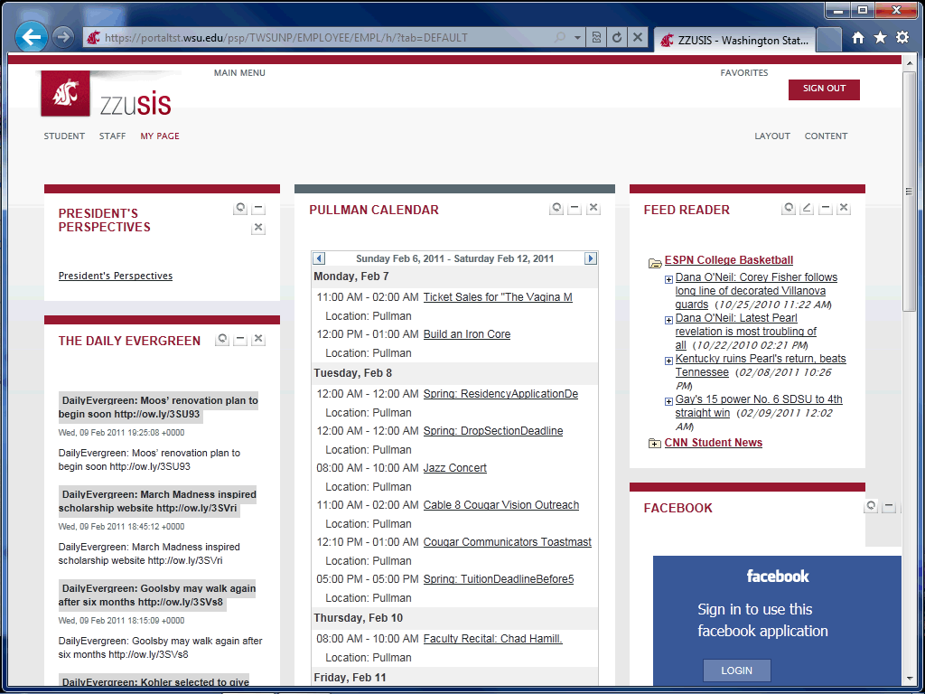

Step | Action
You can drag and drop pagelets in your tabs. Click and hold on the title of the pagelet and drag to its new location.
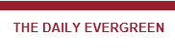
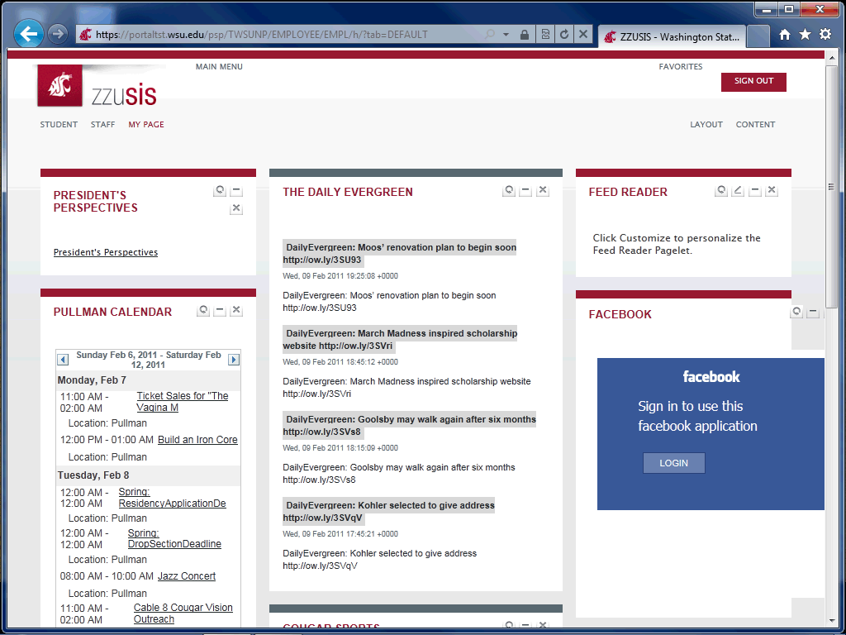

Step | Action
 | Drop your pagelet in its new location.
 | To change the layout of your tab, click the "Layout" link.
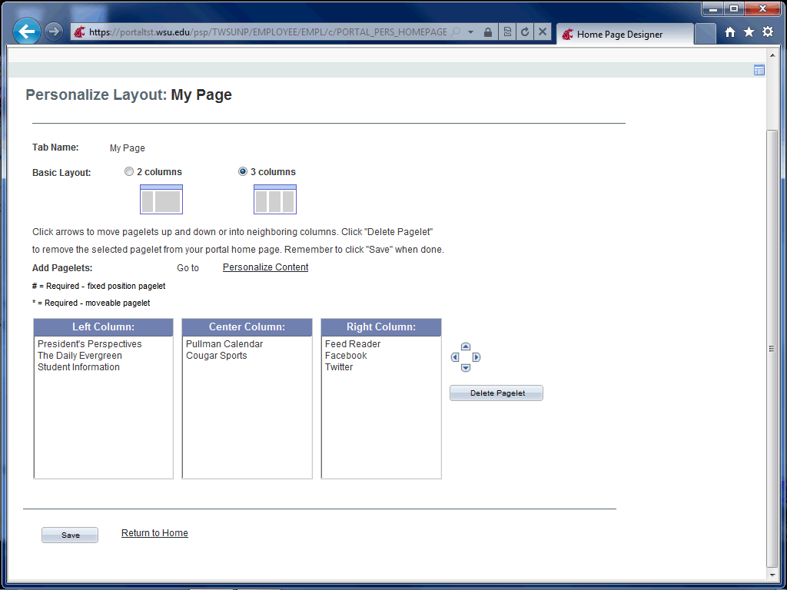

Step | Action
 | Use this page to customize the tab to your specification. Youc an choose two or three columns, and move pagelets for the tab you are currently on. Click "Save" when you are finished.
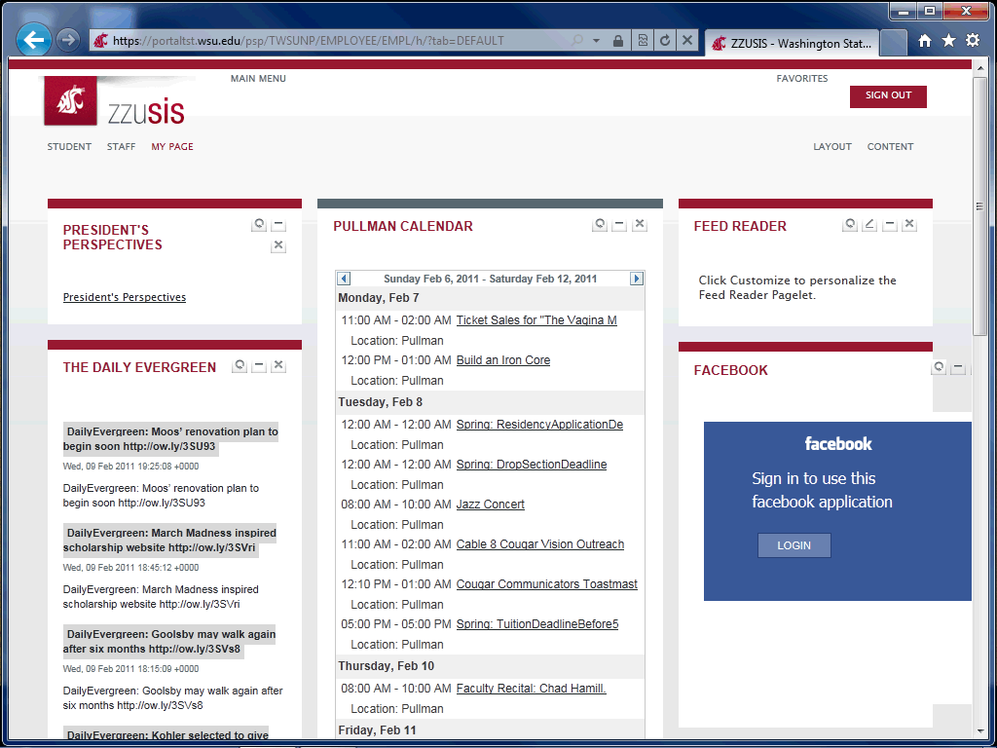

Step | Action
 | To add new content to a tab, click the "Content" link.
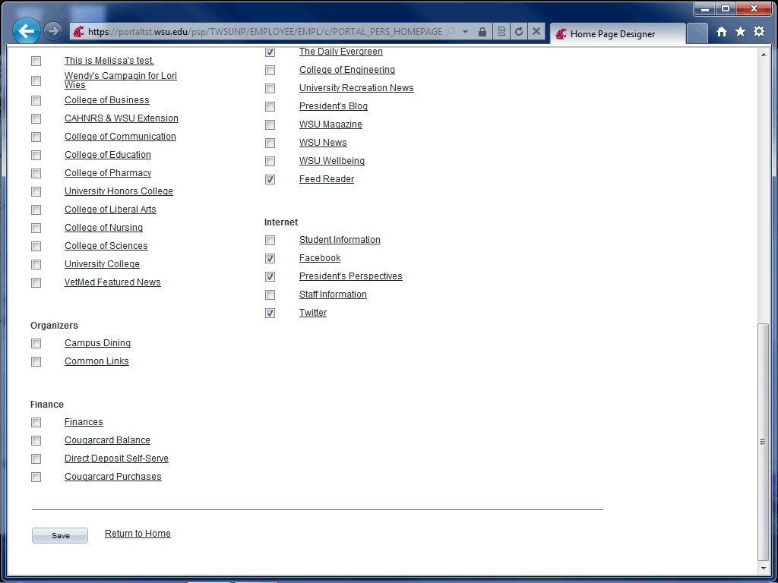

Step | Action
 | Use this page to add pagelets to your tab. Click Save when you are finished.

Step | Action
 | On the "My Page" tab, you will find a Feed Reader pagelet. You can add any RSS Feed to the reader (internal to WSU or external).
 | To add an RSS feed, click on the edit icon.
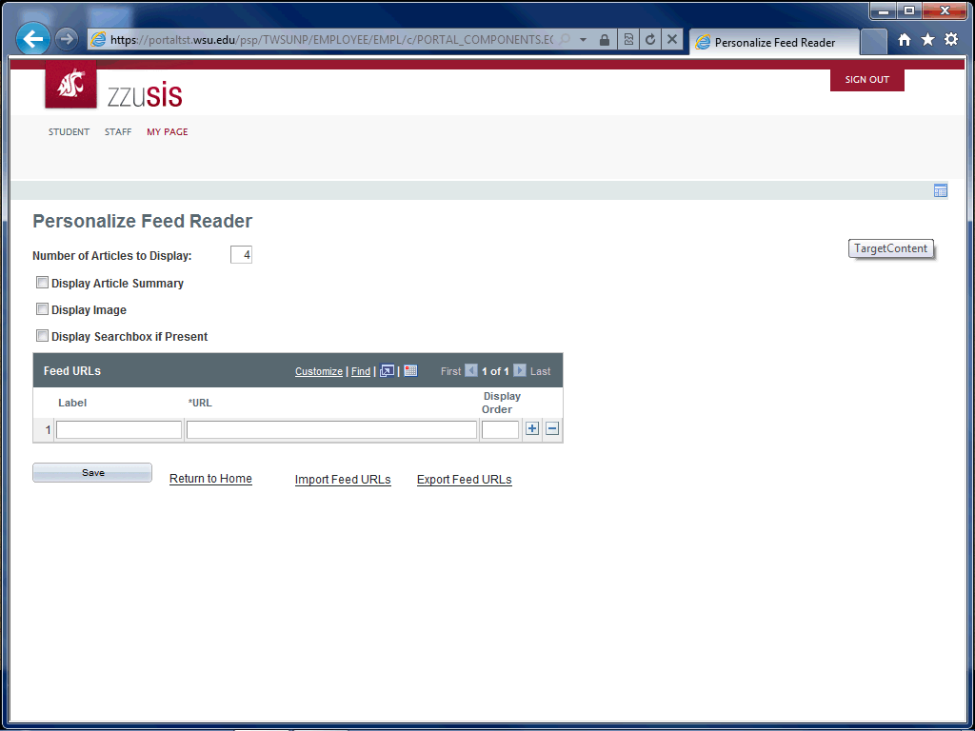

Step | Action
 | Enter the desired information into the boxes for "Label," "URL," and "Display Order." If you would like additional feeds, click the "Add" icon.
 | Once you have added all desired feeds, click the "Save" button.
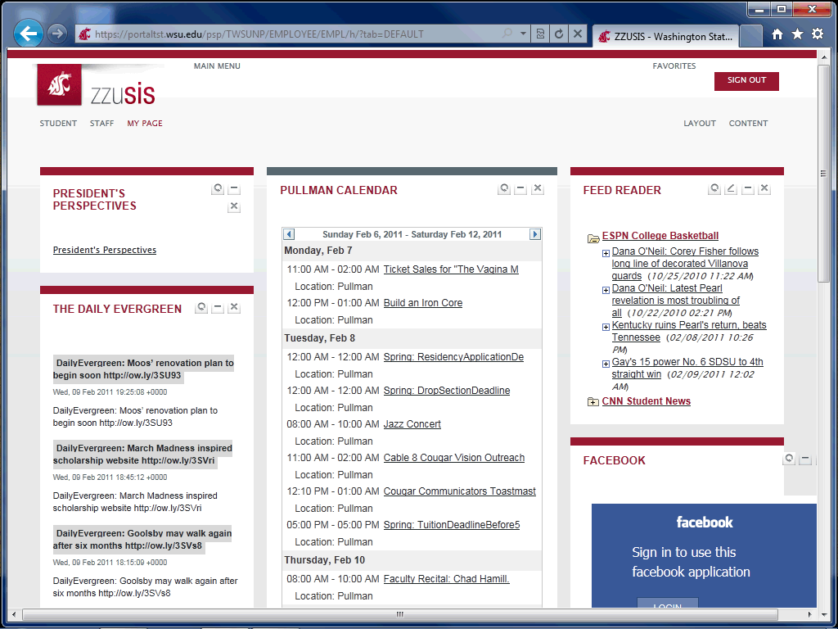

Step | Action
 | You will now see your feeds in your Feed Reader pagelet. To expand the feed, click the folder with the plus sign.
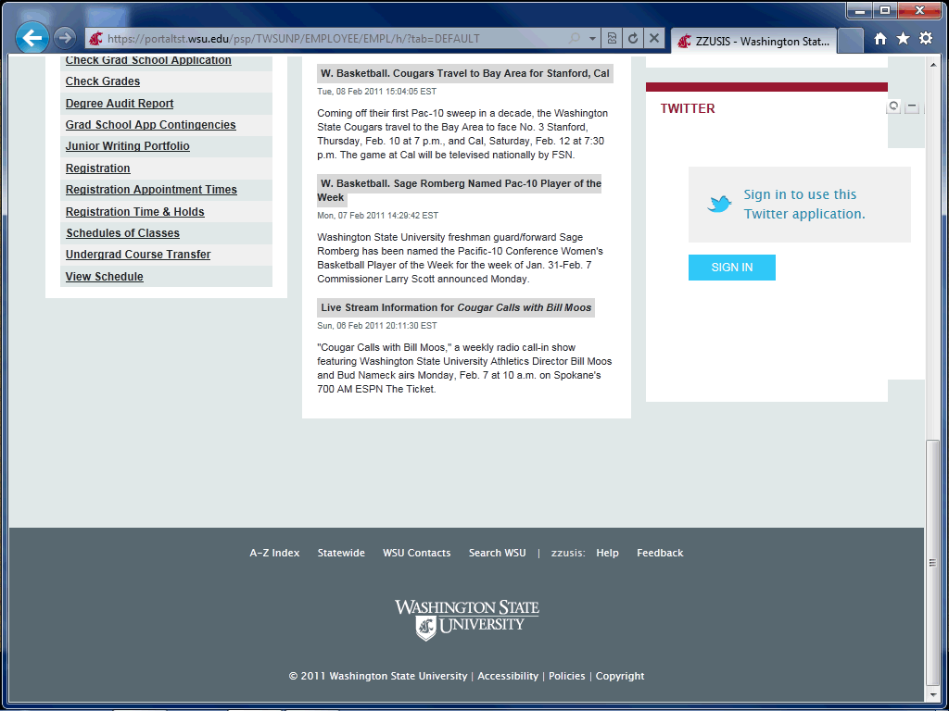

Step | Action
 | If you have feedback for the zzusis portal team, please click the "Feedback" link to send us an email!
Thank you for watching the zzusis portal quick-demo! If you have additional questions, please refer to the portal tutorials or the WSU Help Desk.
End of Procedure.

